SIMATS ENGINEERING
Department of Computer Science and Engineering
ASSESSMENT TOOL 2 – COMPARATIVE ANALYSIS
Course Code: | CSA1220 | Course Title: | Computer Architecture
CO Assessed: | CO4 – Precision (BL4) | Assessment: | Comparative Analysis
Weightage: | 30% | Total Marks: | 100
CO4 Statement: | Implement hierarchical memory systems by differentiating cache levels (L1, L2, L3), virtual memory with paging, and advanced memory technologies (DRAM, SRAM, NAND Flash, MRAM, RRAM) based on latency, bandwidth, and throughput characteristics.
Student Name: | P.Rishitha | Reg. No.: | 192472396
Section / Batch: | B/2024 | Date: | 25/08/2026

Instructions to Students
• Identify the relevant concepts of L1, L2, and L3 cache, SRAM, DRAM, NAND Flash, MRAM, RRAM, virtual memory, paging, latency, bandwidth, and throughput.
• Analyze the memory requirements of different computer systems by considering cache levels, memory technologies, access latency, bandwidth, throughput, capacity, and energy consumption.
• Evaluate the performance characteristics of different memory technologies and determine their suitability for cache memory, main memory, secondary storage, and future hierarchical memory systems.
• Compute relevant performance measures such as access time, latency, bandwidth, throughput, hit/miss rate, average memory access time (AMAT), speedup, and energy efficiency wherever applicable.
• Interpret the results by assessing memory bottlenecks, performance improvements, technology trade-offs, and the suitability of each memory technology or memory hierarchy for a given application.

QUESTIONS
1. Analyze the impact of cache hit rate and miss rate on processor performance. Assess how improving cache locality and reducing cache misses can enhance memory access efficiency and overall execution time.
2. Evaluate the role of memory latency, bandwidth, and throughput in determining system performance. Analyze how variations in these parameters affect applications with different memory-access requirements.
3. Assess the effectiveness of hierarchical memory organization using registers, cache, main memory, and secondary storage. Analyze how differences in access speed, capacity, and cost influence the design of an efficient memory hierarchy.
4. Examine the role of virtual memory and paging in supporting applications that require more memory than the available physical RAM. Analyze the effects of page faults, page replacement, and paging overhead on system latency and throughput.
5. Evaluate different memory technologies for high-performance applications based on latency, bandwidth, throughput, capacity, energy consumption, and endurance. Recommend a suitable memory hierarchy for a selected application and justify the choice based on its performance requirements.
Code of Conduct
I P.Rishitha (192472396) (Name / Reg No) certify that this submission is my original work and that I have adhered to the guidelines specified for this assessment. I understand that any violation of academic integrity rules will result in disciplinary action.
Signature of the Student: P.Rishitha
RUBRICS FOR CALCULATION
Criteria | Weightage(%) | Level 4 – Exemplary (5 Marks) | Level 3 –  Proficient (4  Marks) | Level 2 –  Developing  (2–3 Marks) | Level 1 – Beginning (0–1 Mark)
Scope of Items | 20% | Selects highly  relevant items with clear scope and  justification | Selects  appropriate items with minor gaps | Selection is  limited or partially relevant | Items are unclear or not relevant
Comparison  Depth | 25% | Provides detailed  and comprehensive comparison across multiple aspects | Provides  adequate  comparison with some depth | Limited  comparison with few aspects | Very minimal or no comparison
Use of Evidence | 20% | Supports comparison with accurate data, examples, or  references | Uses some  supporting  evidence with  minor gaps | Limited or weak supporting  evidence | No supporting  evidence provided
Critical  Thinking | 20% | Demonstrates strong critical thinking with clear interpretation and reasoning | Shows  reasonable  interpretation  with minor gaps | Basic  interpretation;  lacks depth | No meaningful  interpretation
Clarity of  Presentation | 15% | Well-organized,  clear, and logically structured  presentation | Generally clear with minor issues | Somewhat unclear or poorly  structured | Disorganized and difficult to  understand

Marks Evaluation:
Q.  No | Scope of Items (20) |  | Comparison  Depth (25) |  | Use of  Evidence (20) | Critical  Thinking (20) | Clarity of  Presentation  (15) | Total  (out of 100)
1 | / 4 |  | / 4 |  | / 4 | / 4 | / 4
2 | / 4 |  | / 4 |  | / 4 | / 4 | / 4
3 | / 4 |  | / 4 |  | / 4 | / 4 | / 4
4 | / 4 |  | / 4 |  | / 4 | / 4 | / 4
5 | / 4 |  | / 4 |  | / 4 | / 4 | / 4
 | / 20 |  | / 25 |  | / 20 | / 20 | / 15 | / 100

Course Coordinator Faculty Incharge

1. Impact of Cache Hit Rate and Miss Rate on Processor Performance
Cache memory is a small, high-speed memory located close to the CPU. It stores frequently used instructions and data so that the processor does not need to access slower main memory every time.

Cache Hit
A cache hit occurs when the required data is found in the cache.
- Access time is very low.
- CPU spends less time waiting.
- Instruction execution becomes faster.
- Overall processor performance improves.

Cache Miss
A cache miss occurs when the required data is not available in the cache and must be fetched from a lower level of memory.
- Memory access takes more time.
- The CPU may stall while waiting.
- Execution time increases.
- Processor performance decreases.
The relationship can be expressed as:
Hit Rate + Miss Rate = 1
A useful performance measure is:
AMAT = Hit Time + (Miss Rate × Miss Penalty)
Where:
- Hit Time = Time required to access the cache.
- Miss Rate = Percentage of accesses that are not found in the cache.
- Miss Penalty = Additional time required to obtain data from lower memory levels.

Improving Cache Locality
Cache locality can be improved using:
- Temporal locality – Reusing recently accessed data.
- Spatial locality – Accessing data located near recently accessed memory locations.
- Loop optimization – Accessing arrays sequentially.
- Blocking techniques – Processing data in smaller blocks that fit into the cache.
- Efficient data structures – Storing related data close together.

Conclusion
A higher cache hit rate reduces the average memory access time and CPU stalls. Similarly, reducing the cache miss rate improves memory access efficiency and decreases overall execution time. Therefore, good cache locality is essential for high processor performance.

IMPLEMENTATION :
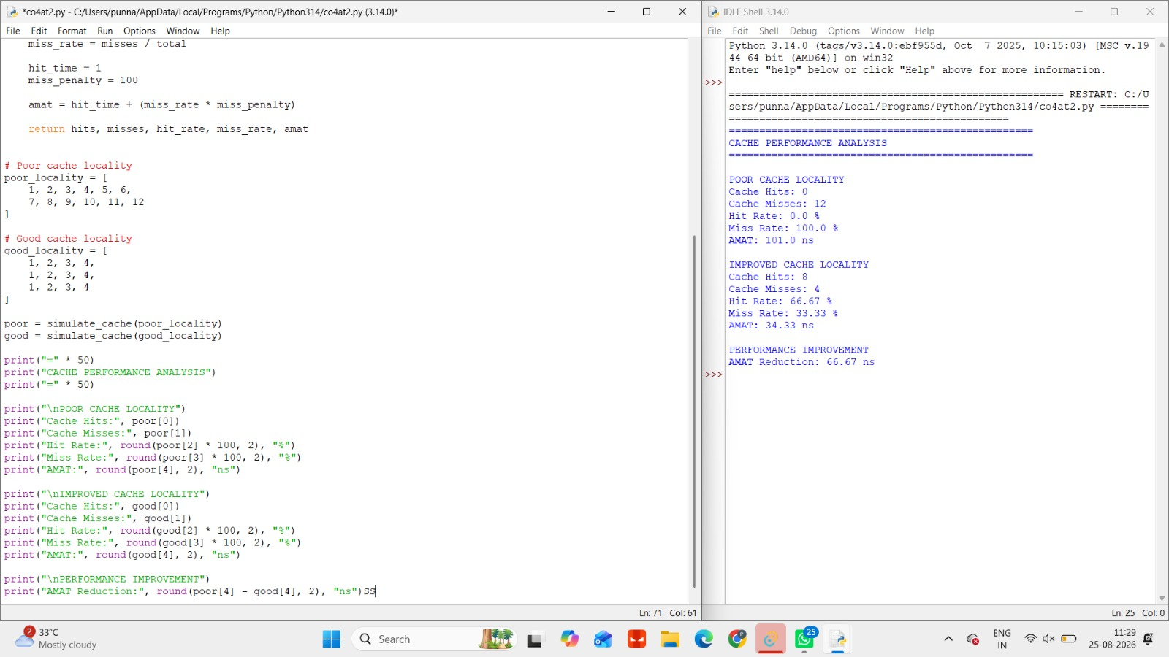

2. Role of Memory Latency, Bandwidth, and Throughput in System Performance
Memory performance depends mainly on latency, bandwidth, and throughput.

1. Memory Latency
Memory latency is the time required to access requested data after a memory request is made.
Lower latency is important for applications that frequently wait for individual memory accesses.
Examples:
- Operating systems
- Databases
- Interactive applications
- Pointer-based data structures
High latency can cause CPU stalls and increase execution time.

2. Memory Bandwidth
Memory bandwidth is the amount of data that can be transferred between memory and the processor per second.
It is important for applications that process large amounts of data.
Examples:
- Video processing
- Machine learning
- Scientific computing
- Graphics processing
Higher bandwidth allows more data to be transferred in less time.

3. Memory Throughput
Memory throughput represents the actual amount of useful memory work completed during a given period.
It depends on factors such as:
- Memory bandwidth
- Latency
- Number of memory requests
- Cache performance
- Memory access patterns

Effect on Different Applications

Application Type | Most Important Parameter | Reason
Database | Low latency | Fast response to many small requests
Machine Learning | High bandwidth | Large amounts of data must be processed
Video Processing | High bandwidth and throughput | Continuous transfer of large data
Operating System | Low latency | Quick access to system data
Scientific Computing | High throughput | Large number of memory operations

Conclusion
Latency affects how quickly an individual memory request is completed, while bandwidth determines how much data can be transferred per second. Throughput represents the effective performance of the memory system. Different applications require different combinations of these parameters.

IMPLEMENTATION :
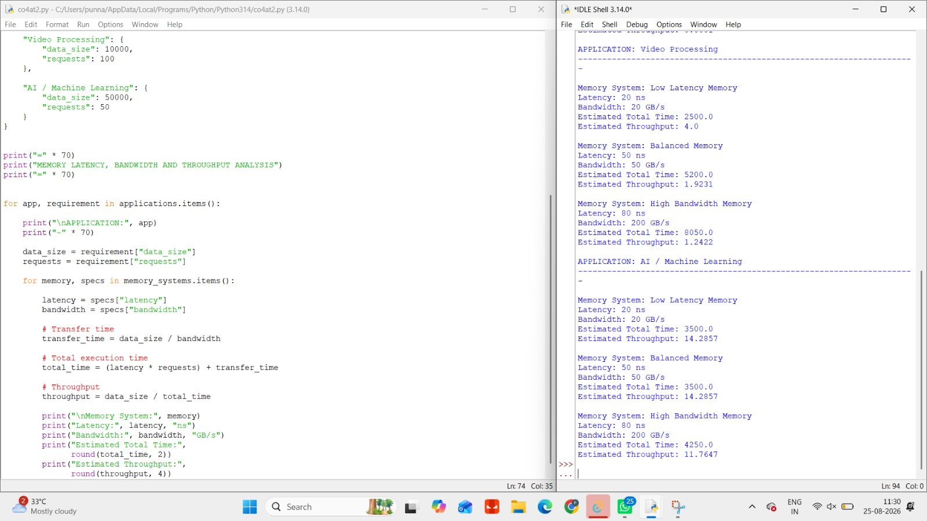

3. Effectiveness of Hierarchical Memory Organization
A computer system uses a memory hierarchy to balance speed, capacity, and cost.
The main levels are:
Registers → Cache → Main Memory → Secondary Storage

Memory Level | Speed | Capacity | Cost per Bit
Registers | Very High | Very Low | Very High
Cache | High | Low | High
Main Memory (RAM) | Medium | High | Medium
Secondary Storage | Low | Very High | Low

1. Registers
Registers are located inside the CPU.
- Fastest memory.
- Used for immediate calculations.
- Very limited capacity.
- Expensive to implement.

2. Cache Memory
Cache stores frequently accessed instructions and data.
- Faster than RAM.
- Larger than registers.
- Reduces processor waiting time.
- More expensive than main memory.

3. Main Memory
Main memory stores currently running programs and data.
- Larger capacity than cache.
- Slower than cache.
- Provides a balance between cost and performance.

4. Secondary Storage
Secondary storage includes SSDs and hard drives.
- Very large capacity.
- Lower cost per bit.
- Much slower than RAM.
- Used for permanent storage.

Importance of Memory Hierarchy
The hierarchy works because programs usually show:
- Temporal locality – Recently used data is likely to be used again.
- Spatial locality – Data near recently accessed locations is likely to be accessed.
Frequently used data is kept in faster memory, while less frequently used data remains in larger and slower memory.

Conclusion
Memory hierarchy provides an effective balance between high speed, large capacity, and low cost. Without this organization, building an entire system using only very fast memory would be extremely expensive, while using only slow memory would significantly reduce processor performance.
IMPLEMENTATION :

4. Role of Virtual Memory and Paging
Virtual memory allows a program to use more memory than the physically available RAM.
It creates the illusion of a large continuous memory space by using a combination of:
- Physical RAM
- Secondary storage

Paging
Virtual memory divides memory into fixed-size units called:
- Pages – Virtual memory blocks.
- Frames – Physical memory blocks.
When a program needs a page that is not currently available in RAM, the operating system loads it from secondary storage.

Page Fault
A page fault occurs when a required page is not present in physical memory.
The operating system must:
- Detect the missing page.
- Locate it in secondary storage.
- Find an available frame or select a page for replacement.
- Load the required page into RAM.
- Resume program execution.
Because secondary storage is much slower than RAM, page faults can significantly increase system latency.

Page Replacement
If RAM is full, the operating system selects an existing page to remove.
Common algorithms include:
- FIFO
- LRU
- Optimal Page Replacement
An inefficient replacement algorithm can cause frequent page faults.

Effects on Performance
Factor | Effect
More Page Faults | Higher execution time
Frequent Paging | Increased overhead
Efficient Page Replacement | Better memory utilization
Excessive Paging | Reduced throughput
Thrashing | Severe performance degradation

Thrashing
Thrashing occurs when the system spends most of its time moving pages between RAM and secondary storage instead of executing programs.
This leads to:
- High latency
- Low CPU utilization
- Reduced system throughput
- Slow application performance

Conclusion
Virtual memory enables large applications to execute even when physical RAM is limited. However, excessive page faults and paging operations increase latency and reduce throughput. Efficient page replacement and sufficient RAM are essential for good performance.
IMPLEMENTATION :
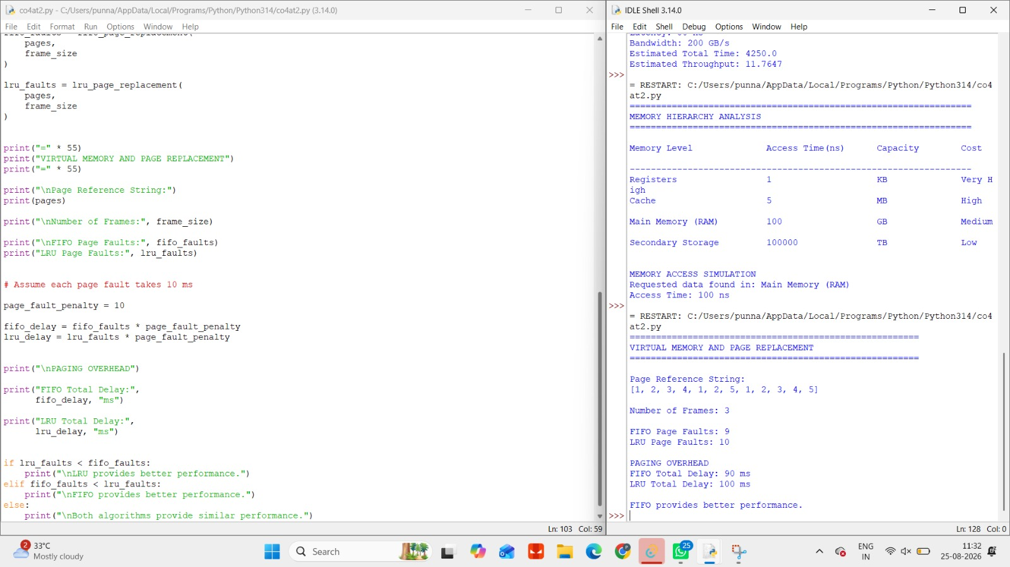

5. Evaluation of Memory Technologies for High-Performance Applications
Different memory technologies provide different levels of performance, capacity, energy efficiency, and endurance.

Memory Technology | Latency | Bandwidth | Capacity | Energy Consumption | Endurance
SRAM | Very Low | Very High | Low | High per bit | Very High
DRAM | Low/Medium | High | High | Moderate | High
HBM | Low | Very High | Medium | Good efficiency | High
SSD / NAND Flash | High | Medium/High | Very High | Low | Limited write endurance
HDD | Very High | Low | Very High | Moderate | High mechanical limitations

Selected Application: Artificial Intelligence and Machine Learning
AI and machine learning applications require:
- Fast data access
- High memory bandwidth
- Large memory capacity
- High throughput
- Energy-efficient operation
A suitable memory hierarchy would be:
CPU/GPU Registers → SRAM Cache → HBM/DRAM → SSD Storage

Explanation

Registers
Used for immediate calculations inside the processor.
- Extremely fast.
- Very small capacity.

SRAM Cache
Stores frequently used data and instructions.
- Low latency.
- Reduces access to slower memory.

HBM or High-Bandwidth DRAM
Suitable for AI and GPU-based workloads.
- Provides very high bandwidth.
- Supports large-scale parallel processing.
- Improves throughput for large datasets.

SSD Storage
Used for storing:
- Large datasets
- AI models
- Training data
- Application files
SSDs provide much faster access than traditional hard drives.

Recommended Memory Hierarchy
Registers → L1/L2/L3 SRAM Cache → HBM or DDR DRAM → NVMe SSD

Justification
This hierarchy provides:
- Low latency through registers and cache.
- High bandwidth through HBM or high-performance DRAM.
- Large capacity through DRAM and SSD storage.
- Good throughput for parallel AI operations.
- Better energy efficiency compared with relying heavily on slower storage.

Final Conclusion
For high-performance applications such as AI, scientific computing, and graphics processing, an efficient memory hierarchy should combine very fast small memories with larger and slower memories. Registers and cache provide low latency, HBM/DRAM provides high bandwidth and capacity, and SSD storage provides large, non-volatile storage. This combination offers a good balance between performance, capacity, energy consumption, cost, and endurance.
IMPLEMENTATION :
